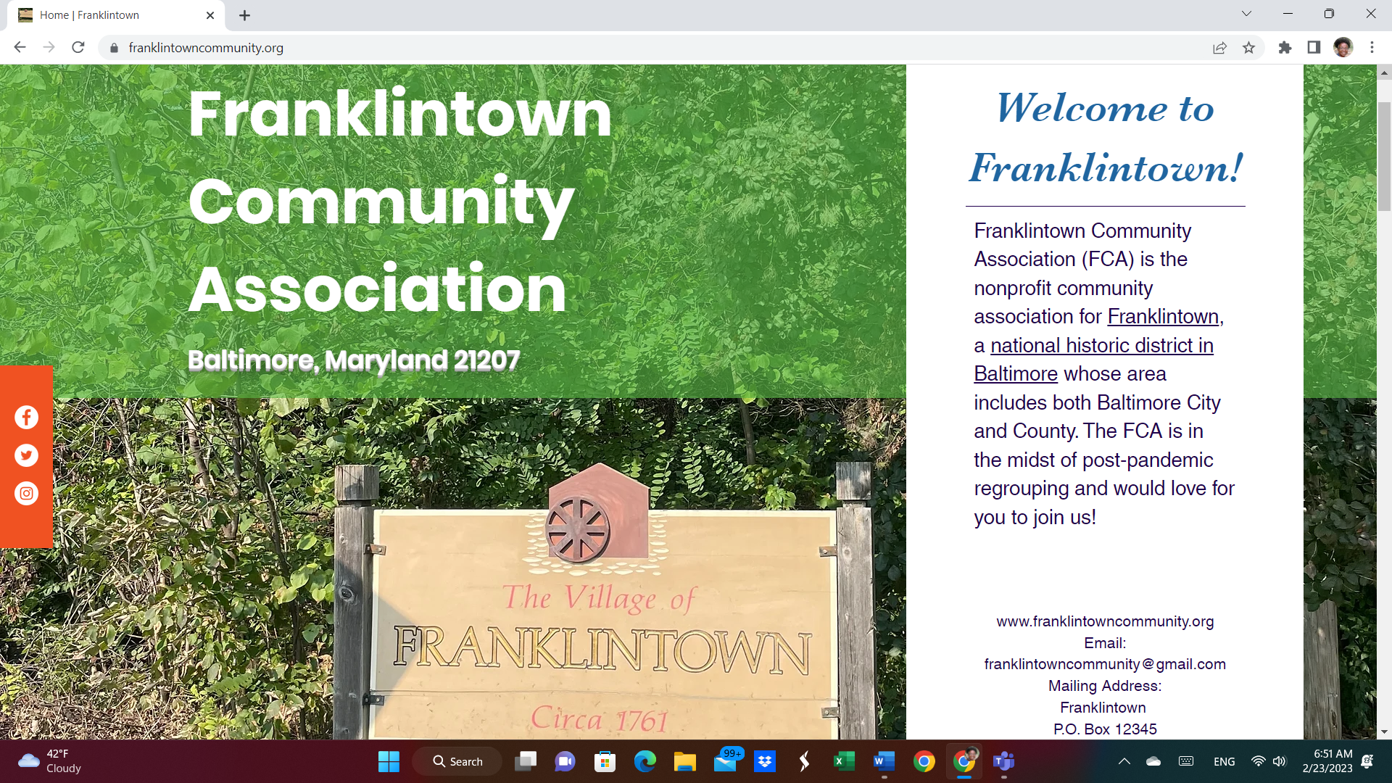
Franklintown Community Association (FCA) Board members want to say, “Hi Neighbors old and new!!!” We are looking forward to getting to know each other and making this the best place ever for family and business.
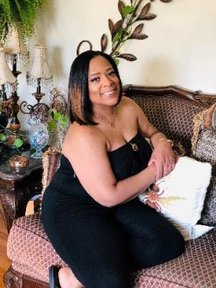

Raquel Bailey, FCA President
Welcome to the Franklintown Community Association (FCA)
My name is Raquel Bailey, I have lived in this community since 2000 and was recently voted into the position of president in November 2022. Being a retired law enforcement officer, it is no surprise my focus is on community safety and to promote interaction opportunities between members, developing a genuine connection. To accomplish this goal, I need you. This is no one man show. It takes all of us to maintain a safe, inviting community everyone loves and wants to live in. Get involved by visiting our website at http://www.FranklintownCommunity.org
Bienvenido a la Asociación Comunitaria de Franklintown (FCA)
Mi nombre es Raquel Bailey, he vivido en esta comunidad desde el año 2000 y recientemente fui elegida para el cargo de presidenta en noviembre de 2022. Siendo un oficial de policía retirado, no es de extrañar que mi enfoque esté en la seguridad de la comunidad y en promover oportunidades de interacción entre los miembros, desarrollando una conexión genuina. Para lograr este objetivo, te necesito. Este no es un espectáculo de Se necesita de todos nosotros para mantener una comunidad segura y acogedora que todos aman y en la que quieren vivir. Participe, visite nuestro sitio web en http://www.FranklintownCommunity.org un solo hombre.

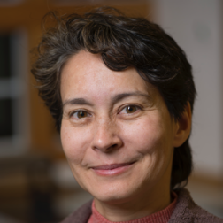
Beatrice Kondo, FCA Vice-President

I’m Beatrice Kondo, and I’ve lived here since 2010. I joined the Franklintown Community Association a few years after that, and eventually joined the Board. I am presently serving as the Vice President. Things I like about this community include that it’s stable… people tend to buy homes and stay here. There are parks all around, Including Dead Run, the Lorraine Park Cemetery, and Gwynn Falls Leakin Park, one of the largest urban parks in the United States. The community association maintains close ties with the city and county governments, which is important for everything from road maintenance to strategic planning and development, as well as code enforcement and public safety. Please consider joining us and helping to steer your community in a positive direction.

Soy Beatrice Kondo y vivo aquí desde 2010. Me uní a la Asociación Comunitaria de Franklintown unos años después y finalmente me uní a la Junta. Actualmente me desempeño como vicepresidente. Las cosas que me gustan de esta comunidad incluyen que es estable... la gente tiende a comprar casas y quedarse aquí. Hay parques por todas partes, incluyendo Dead Run, el cementerio de Lorraine Park y el parque Gwynn Falls Leakin, uno de los parques urbanos más grandes de los Estados Unidos. La asociación comunitaria mantiene vínculos estrechos con los gobiernos de la ciudad y el condado, lo cual es importante para todo, desde el mantenimiento de las carreteras hasta la planificación y el desarrollo estratégico, así como la aplicación de códigos y la seguridad pública. Por favor considere unirse a nuestra asociación para ayudar a guiar a nuestra comunidad en una dirección positiva.
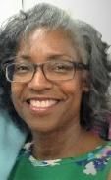

Pamela Cheeseboro, FCA Secretary
Hi, I’m Pamela Cheeseboro and I am currently secretary of the Franklintown Community Association. Primarily this position keeps records of board and general meetings and facilitates keeping on track with communication between the association, its members, other community organizations and local officials. I have lived in the community of Franklintown since 1999. This is my second year serving in this position. I enjoy many of the amenities such as the park, golf course and the Cahill Wellness Center. My recent passion is gardening, and I need HELP!!! (LOL)The best way to get in contact with me is through the Franklintown email franklintowncommunity@gmail.com or our web site at http://www.franklintowncommunity.org. I hope you will consider becoming an active member of the association all voices are needed for us to function at our best.
Hola, soy Pamela Cheeseboro y actualmente soy secretaria de la Asociación Comunitaria de Franklintown. Principalmente, esta posición mantiene registros de la junta y las reuniones generales y facilita el seguimiento de la comunicación entre la asociación, sus miembros, otras organizaciones comunitarias y funcionarios locales. He vivido en la comunidad de Franklintown desde 1999. Este es mi segundo año sirviendo en este puesto. Disfruto de muchas de las comodidades, como el parque, el campo de golf y el Cahill Wellness Center. ¡Una pasión reciente es la jardinería y necesito AYUDA! (LOL) La mejor manera de ponerse en contacto conmigo es a través del correo electrónico de Franklintown franklintowncommunity@gmail.com o nuestro sitio web en http://www.franklintowncommunity.org. Espero que considere convertirse en un miembro activo de la asociación. Todas las voces son necesarias para que podamos funcionar de la mejor manera.

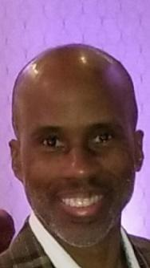
Jarmael “Jay” Burman, FCA Treasurer (Tesorero)
I was an association member for over 25 years, before officially becoming an FCA Board Member, I actively participated in community association-sponsored events, but for the past three years, I have served as Treasurer of the FCA. Franklintown has been home to me for nearly 30 years. I enjoy cycling and hiking and as an outdoor enthusiast find Franklintown to be a hidden gem.
Durante más de 25 años, antes de convertirme oficialmente en miembro de la junta de FCA, participé activamente en eventos patrocinados por asociaciones comunitarias, pero durante los últimos tres años me desempeñé como tesorero de FCA.
Franklintown ha sido mi hogar durante casi 30 años.
Disfruto del ciclismo y el senderismo y, como entusiasta de las actividades al aire libre, considero que Franklintown es una joya escondida.

Rosa Gray, FCA Board Member
“Protect homeowners' property values. Provide services for homeowners and renters.
Develop a sense of community through social activities and amenities.”
These are just some of the reasons I joined the FCA. I have lived in this community for 30 years
and love the forest-like environment, shared with people, pets and semi-wild animals!
My goal is to serve the Franklinton Community and surrounding neighborhoods.
keeping it a safe and valued community.

“Proteja los valores de propiedad de los propietarios. Proporcionar servicios para propietarios e inquilinos.
Desarrollar un sentido de comunidad a través de actividades sociales y comodidades”.
Estas son solo algunas de las razones por las que me uní a la FCA. Hace 30 años que vivo en esta comunidad
¡y ama el entorno boscoso, compartido con personas, mascotas y animales semisalvajes!
Mi objetivo es servir a la comunidad de Franklinton y los vecindarios circundantes.
manteniéndola como una comunidad segura y valiosa.

Wayne Harris, FCA Board Member
Welcome to the Franklintown Community Association (FCA)
My name is Wayne D Harris Sr, I have lived in this community since 2016 and I am currently a board representative of your Franklintown Community Association. I am a lifelong resident of Baltimore City, a veteran, and I am currently the 9-1-1 Operations Manager for the City of Baltimore. Knowing the violence that our city faces daily; I want to make sure this little town I call home is taken care of. To accomplish this goal, I need you. This is no one man show. It takes all of us to maintain a safe, inviting community everyone loves and wants to live in. Get involved by, visiting our website at http://www.FranklintownCommunity.org

Bienvenido a la Asociación Comunitaria de Franklintown (FCA)
Mi nombre es Wayne D Harris Sr, he vivido en esta comunidad desde 2016 y actualmente soy miembro de su Asociación Comunitaria de Franklintown. Soy un residente de toda la vida de la ciudad de Baltimore, un veterano, y actualmente soy el Gerente de Operaciones del 9-1-1 para la Ciudad de Baltimore. Conociendo la violencia que nuestra ciudad enfrenta todos los días, quiero asegurarme de que esta pequeña ciudad a la que llamo hogar sea atendida. Para lograr este objetivo, te necesito. Este no es un espectáculo de un solo hombre. Se necesita de todos nosotros para mantener una comunidad segura y acogedora que todos aman y en la que quieren vivir. Participe, visite nuestro sitio web en http://www.FranklintownCommunity.org

Welcome to our community!

Franklintown Community Association is a joint association of the communities of Franklintown and Windsor Terrace. The borders are Gwynn Falls/Leakin Park to the east, Windsor Mill Road to the north, Dogwood Road to the south, and Lorraine Park Cemetery to the west. Additionally, north of Windsor Mill Road, the streets between the Kernan Hospital complex and the Shaarei Tfiloh Cemetery are included. Altogether, there are about 500 homes within the Franklintown Community Association area.

Franklintown was begun in 1932, and features the beautiful Franklintown Inn, as well as many other historic buildings. In the southeast corner of Franklintown is Franklintown Historic District. By contrast, the first house in Windsor Terrace was built in 1920, and most of the homes were built in the 1940s-1960s. There has been moderate new home construction in both Windsor Terrace and Franklintown, but the communities are mostly old, established homes. Both areas are predominantly single family homes, with some apartments and townhomes in the northeast quadrant of Franklintown.

Because the community spans Baltimore City and Baltimore County, the community organization maintains a close working relationship with legislative representatives and police community liaisons from both areas. We are also a member organization of the Forest Park Action Council, which is a joint organization that includes communities and businesses in the area, working for public safety and community enhancement.

All residents of the community are automatically members of the community association, however only dues-paying members are eligible to vote for our community board, or to serve on the board. We hope you will consider joining the Franklintown Community Association, and help to make our neighborhoods a safe and vibrant home for everyone!

Raquel Bailey
FCA Board President

Our Franklintown Community and very close neighbors
So Much to Offer
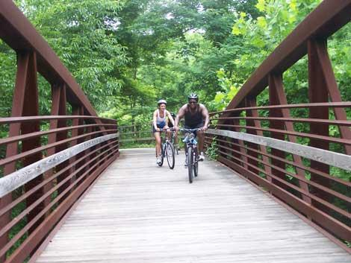
Gwynn Falls Trails
- Hiking
- Bike Trails
- Tennis Courts
- Miniature Train Rides

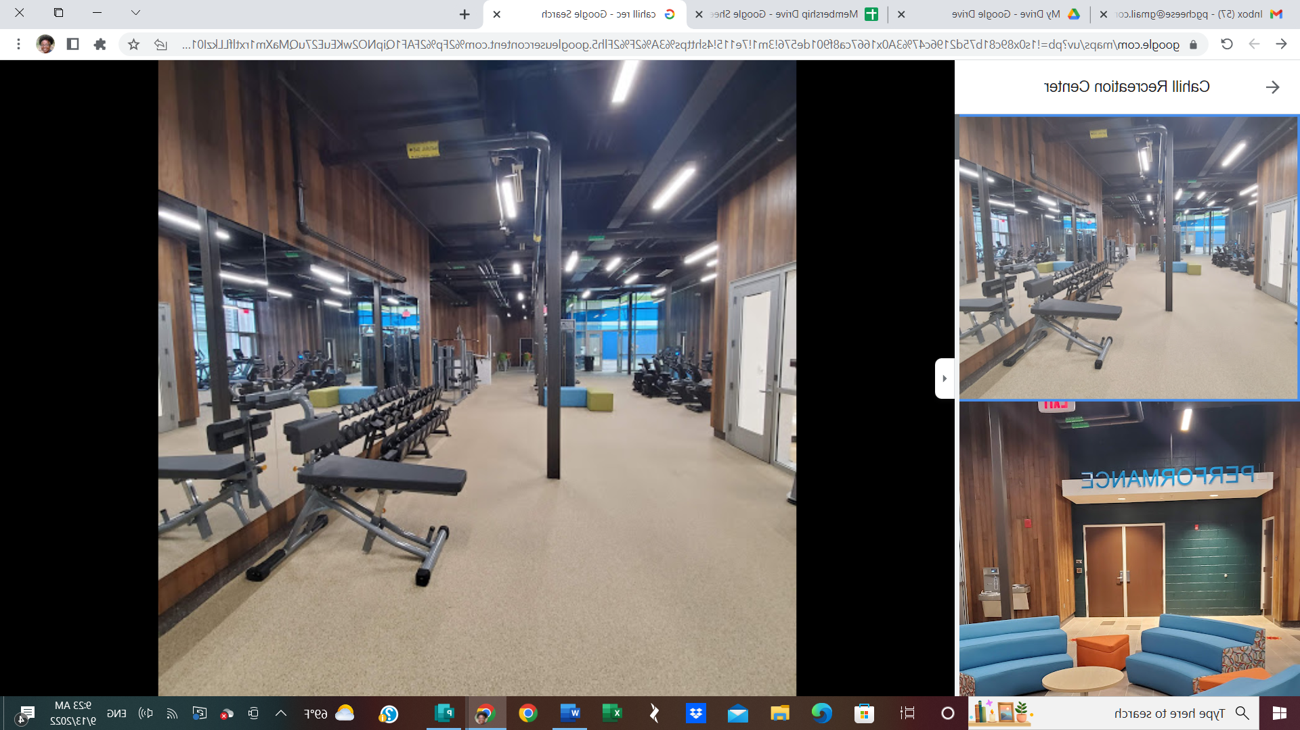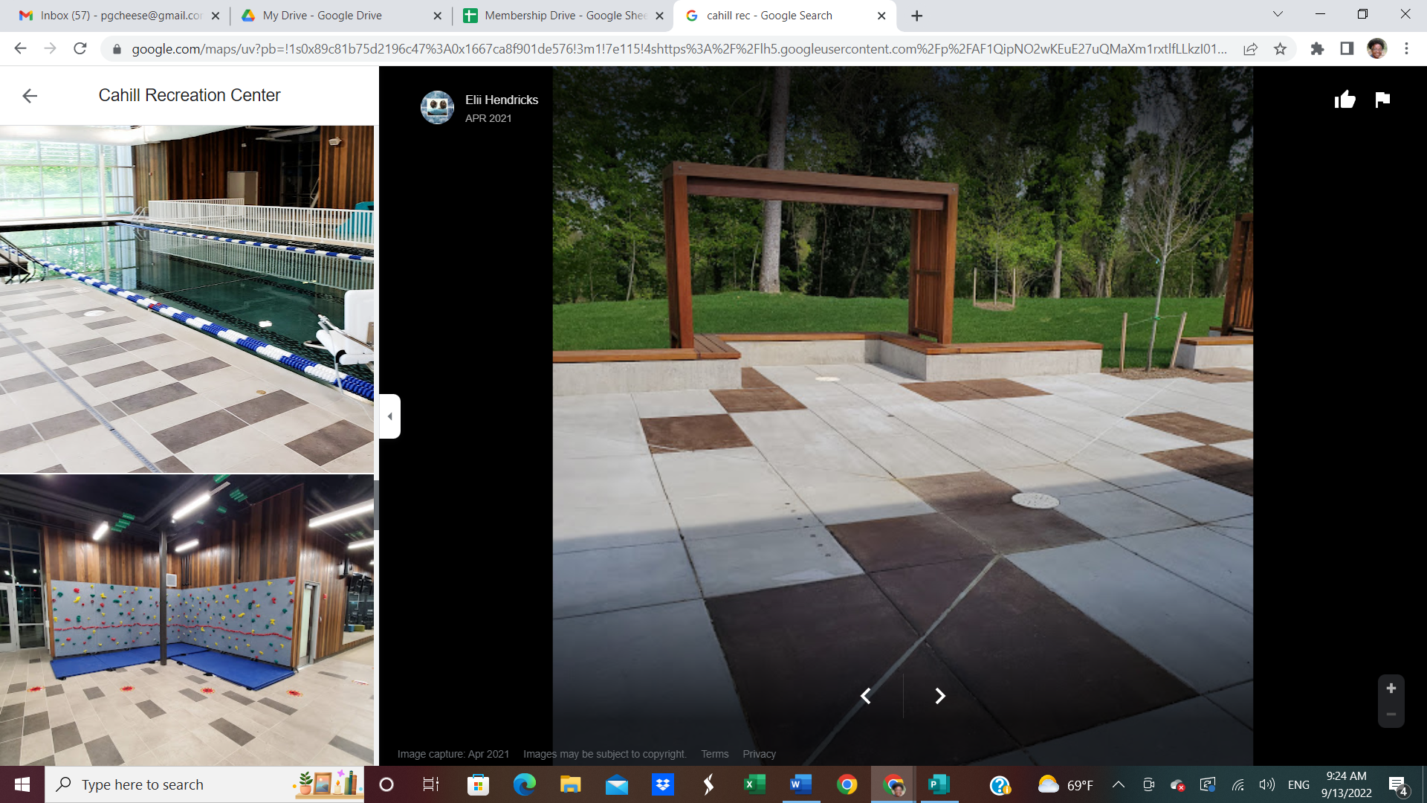 Cahill Wellness Center (Windsor Hills)
- Zumba
- Nautilus Equipment
- Multiple Wellness Classes
- Programs for Youth
- Swimming

Forest Park Golf Course (Hillsdale) 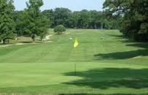
- Home of First Tee - Youth Golf Training Program
- Beautiful Public Course
Carrie Murray Nature Center
- Animal Rescue
- Tours
- Children’s School Break Camps

University of Maryland Rehabilitation & Orthopedic Institute
Services Provided at this Hospital.
- Adapted Sports
- Amputee Rehab
- Brain Injury
- Cleft Lip and Palate Repair
- Dental Services
- Orthopedics
- Outpatient Therapies & Services
- Pain Management
- Parkinson's Disease
- Rehabilitation
- Rheumatology
- Stroke Recovery
- Therapeutic Interventions
- Therapeutic Technology
Outward Bound
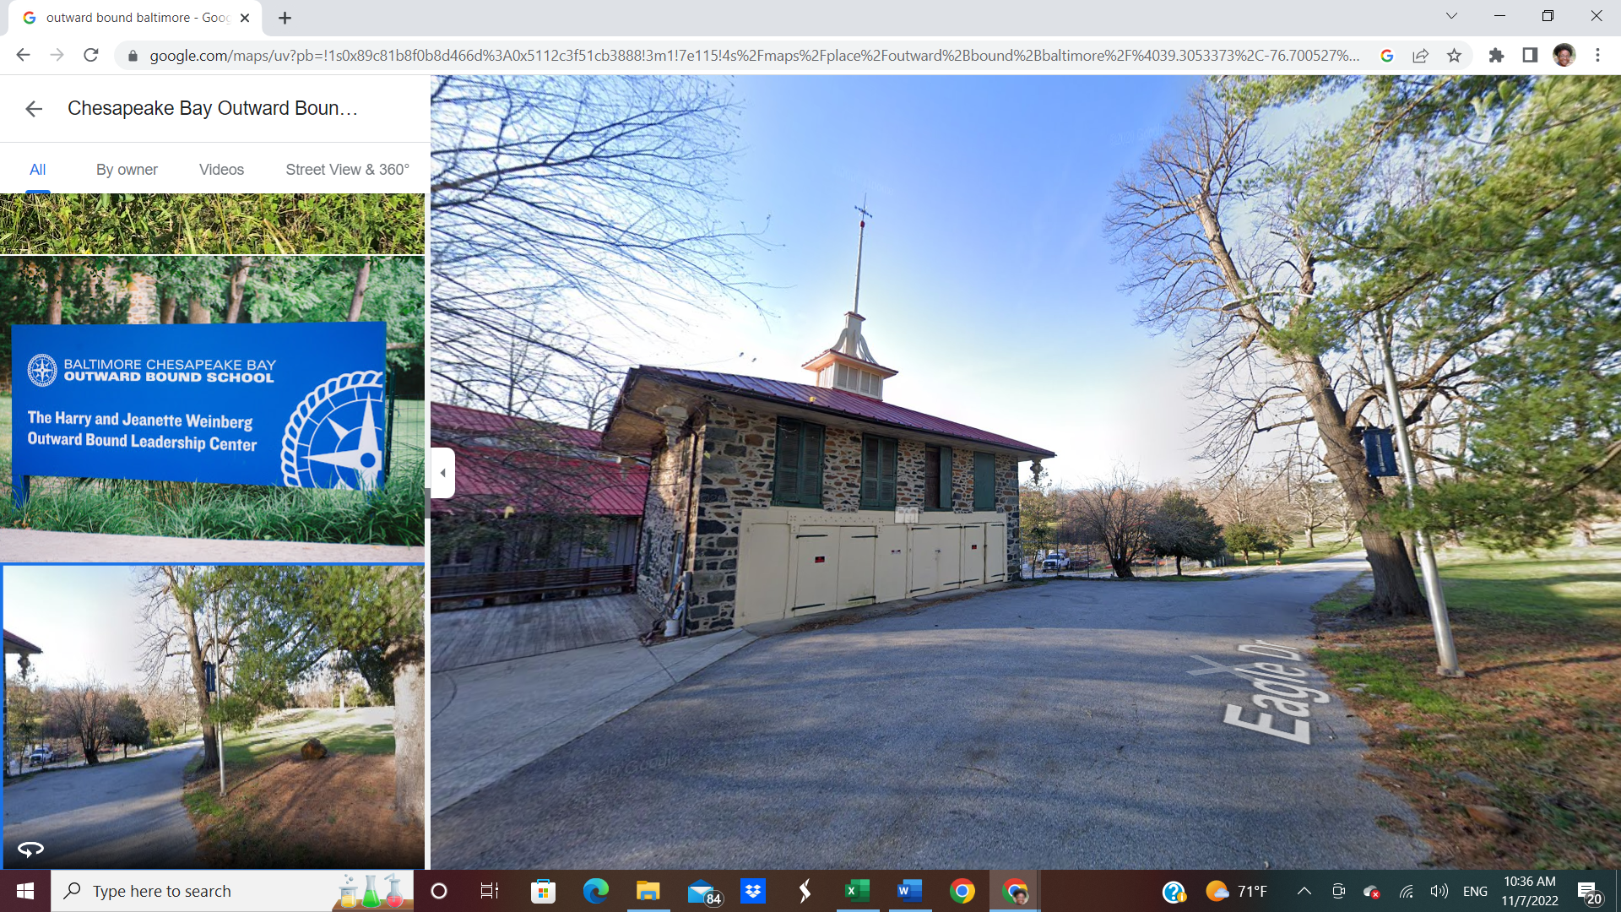
Dickey Hill Elementary/Middle School
Martin Luther King Memorial Methodist Church

St Mary’s Episcopal Church

Our Franklintown Businesses – Supporting Our Local Community

TOLA AFRICAN BRAIDING FITUATION ROOM 5201
5209 Muth Ave 5201 No Franklintown Rd
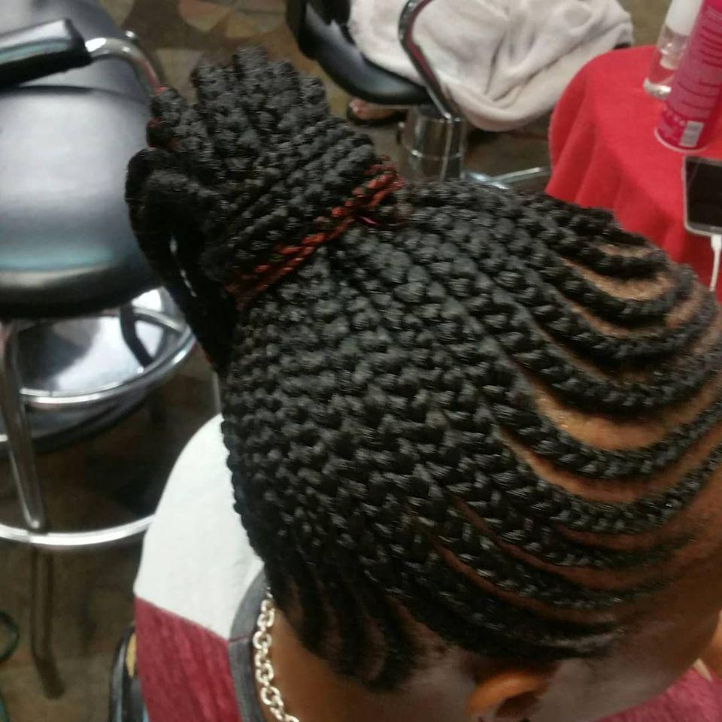
10% discount on all services First three classes free

LOVING HEARTS 5201 Franklintown Rd CARROLL FUEL Windsor Mill Rd/Forest Park Ave

FRED’S GARAGE 5304 Dogwood Rd MILLSTREAM INN - 5310 Dogwood Rd
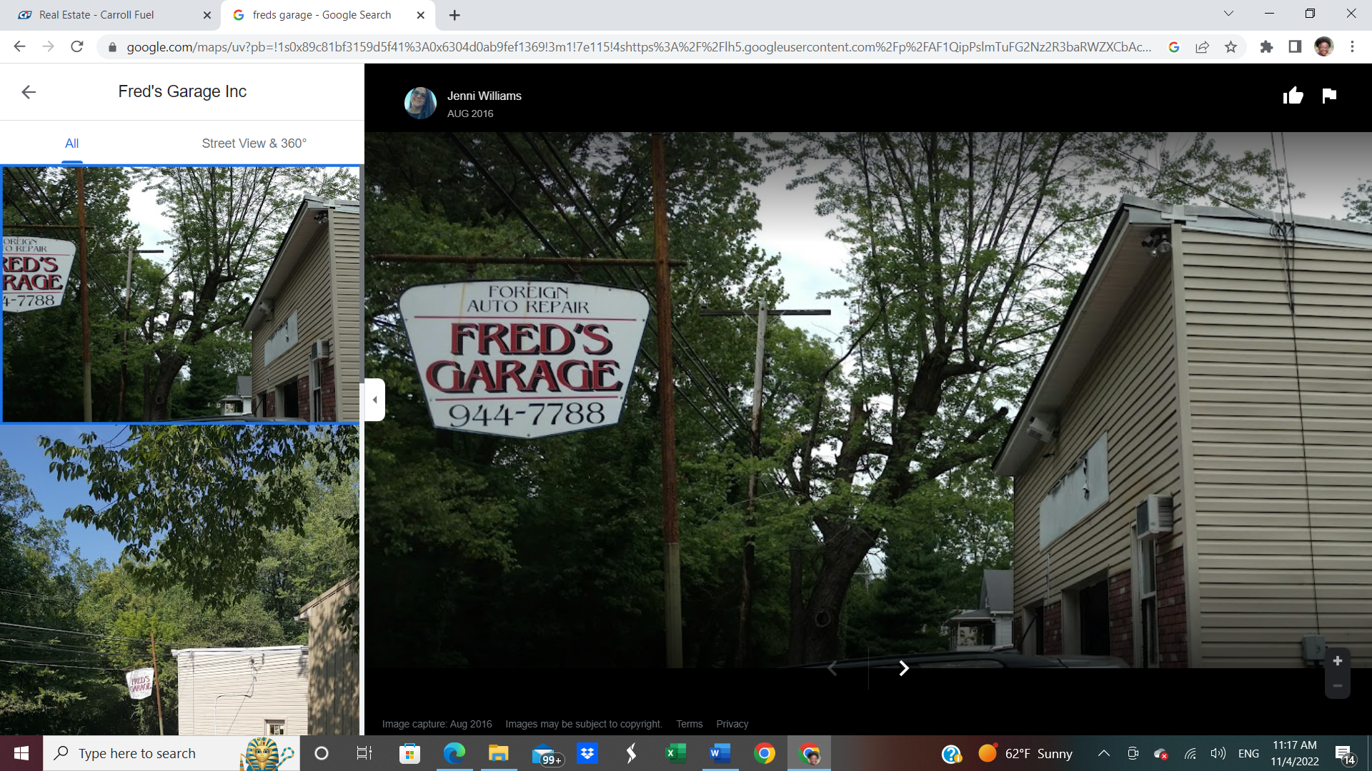

SUBWAY - 5209 Windsor Mill Rd ROYAL FARMS – 2000 N Forest Park

FRANKLINTOWN INN Bullwinkles
5200 Franklintown Road Ingleside/Dogwood Rd – 1660 Ingleside Ave.

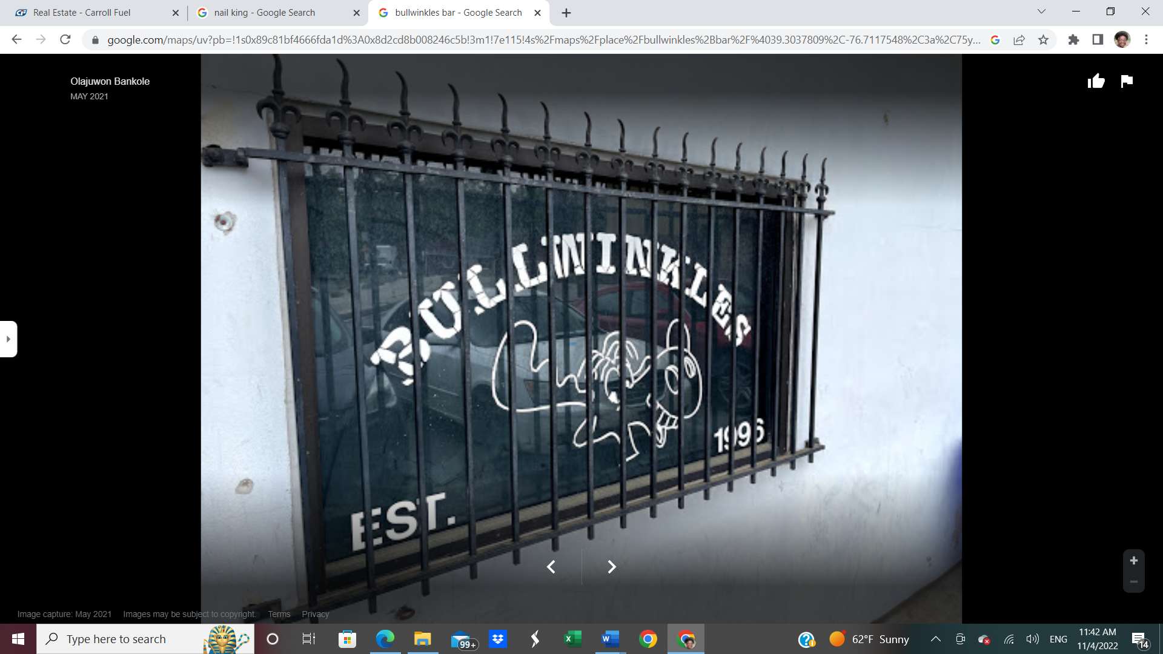
Always supportive in providing space for
community meetings

Cardinal Construction 3 D’s Tax Service
1620 St Agnus Lane 5201 No Franklintown Road

Henri’s Auto Service Lorraine Park Cemetary
5816 Windsor Mill Rd 5608 Dogwood Road

WS Tegeler Co Woodlawn Pets and More
5761 Windsor Mill Rd 5804 Windsor Mill Rd
410 944 0300 443 840 7466
vvv

Beth Shalom Envy Auto Care Center
Hebrew Young Men’s Cemetery 44823 Windsor Mill Rd
5800 Windsor Mill Road 410 448 1130
410 531 5115

